Llangattock Community Council

Telephone conversation with Tim Jones Vice Chair of Llangattock Community Council and Chair of the Community Committee

In May 2023 undertook community consultation to inform a Community Place Plan.

Cost of producing the plan £1700

Alongside this Kate Inglis (Councillor at the time) undertook a consultation/study into transport provision to Crickhowell – how outlying communities were able to access the hub town of Crickhowell.

The Llangattock and Crickhowell place plans both reference the work that Kate has been undertaking.

https://www.llangattock-cc.gov.wales/wp-content/uploads/2024/06/Adopted-Llangattock-Community-Plan-and-Report-of-Consultation-18th-June-2204.pdf

From the plan:

Public Transport

The BBNPA Management plan calls for shifts in transport systems from fossil

fuel to renewables with a need to create viable and sustainable public

transport and active travel options.

As of 2024, there are 5 buses a day to and from Llangattock. These only serve

the centre of the village and none at normal travel-to-work times. Not

everyone is able to walk to Crickhowell to catch a bus there and inclement

weather discourages others. Increasing the frequency, reliability, and punctuality of public transport

into and out of Llangattock would help LCC and BBNPA achieve their carbon emission reduction

targets. There is no public transport in Legar, Dardy, Ffawyddog, or Hillside, but these routes may

not viable for service operators. Ffawyddog residents report difficulties persuading taxi companies

to take them there.

In the survey, the service from the centre of the village was generally supported, with reservations

about frequency and reliability. However some people said they would be more inclined to use the

bus if there was a shelter. Others also complained about poor connections to Crickhowell services

and beyond. While the bus service is accessible, residents have requested a bus shelter to protect

them from the weather and give them somewhere to sit while waiting for a bus.

In 2023, LCC obtained grant funding to examine the feasibility of an electric shuttle bus running

between the five council areas of Llangattock, Crickhowell, Llangynidr, Cwmdu and Glangrwyney.

There is currently limited intra-community transport between the five Councils and none between

the communities within Llangattock. Since the closure in 2023 of the Gilwern surgery (an off-shoot

of Crickhowell Health Centre) there is a strong argument for including Gilwern in a Crickhowell local

transport ‘hub’.

• LCC will work with PCC to develop active travel routes in Llangattock, continue to lobby for

improvements to the crossing between the bridge over the Usk and the Glebe Field, Llangattock. It will

continue with its attempts to access funding to improve the accessibility of the kissing gates while

maintaining the historic appearance of this part of Llangattock and work with residents to install more

benches along its route.

• LCC continue to lobby for car sharing among parents and walking buses to safely escort children to and

from LCIW school to reduce short journeys by car and ease parking pressures around the school.

• LCC will develop a plan for improving the footpath in the cemetery.

• LCC to continue its work on a feasibility study into green shuttle bus running in and out of

Crickhowell.

• LCC should support the project for a bus shelter at Plas Derwen and investigate options for

serving The Legar.

• LCC should continue to lobby for improvements in the frequency and reliability of bus services

to and from Llangattock including by contributing to PCC’s 2024 consultation.

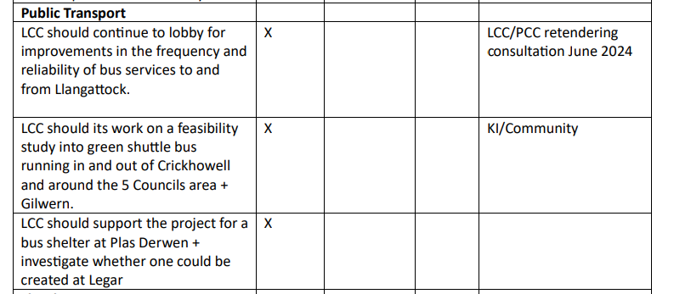

Crickhowell Town Council Place Plan

Cost @£30k

[Crickhowell_Place_Plan_ENG.jpg (website-editor.net)](https://cdn.website-editor.net/s/ecef4876e56348afb2b51c850283098d/files/uploaded/Crickhowell_Place_Plan_ENG.jpg?Expires=1726496469&Signature=NPGXBvOB1Mo2mzP8ppXKaOtQzawKNI39pHo0sH29NUaTcpuCJbXzQqyWciNN2EurSnO9p2Y3ZnfzMjL~QHap1Qg0fM78oE~wyW446JQKUgzFHf5NTd9Mq7V2V-w87~XYjyxSUrUhe2-0C2-2vtBwuaXIAlN77ZlqtoyApsn3qg0H2PranRXvp-rIqMnpEwcnFzOrLHnZn5wTqmcGrpbQq41tVjTwFgclUfYhFB5tE-1OvvFx8lrQJexc~U0jR281VUT1MoUycJ~ifLt3794Qd~deDJW5rOewIdlqeXEx28y1JQi~dfJ9nBuiORlVYRh5~v95rEKQaCygOKFhgGD22w__&Key-Pair-Id=K2NXBXLF010TJW)

Kate Inglis

<https://www.llangattockgreenvalleys.org/>